Make me happy



In this project you will make a Python program that can react to what messages that you send to it.

If you compliment it, it will act happy.

If you insult it, it will act sad.

You’ll use machine learning to train the computer to recognise the difference between kind and mean messages, by giving it examples of each.

This project worksheet is licensed under a Creative Commons Attribution Non-Commercial Share-Alike License

http://creativecommons.org/licenses/by-nc-sa/4.0/

1. You need two pictures: a picture of a happy face, and a picture of a sad face. Draw them, or if you prefer, find pictures on the Internet instead  
   *Save the two pictures somewhere on your computer and remember where you put them. You’ll need them later.*
2. Go to <https://machinelearningforkids.co.uk/> in a web browser
3. Click on “**Get started**”
4. Click on “**Log In**” and type in your username and password  
   *If you don’t have a username, ask your teacher or group leader to create one for you.  
   If you can’t remember your username or password, ask your teacher or group leader to reset it for you.*
5. Click on “**Projects**” on the top menu bar
6. Click the **“+ Add a new project**” button.
7. Name your project “make me happy” and set it to learn how to recognise “**text**”.   
   Click the “**Create**” button  
   
8. You should now see “**make me happy**” in the list of your projects. Click on it.
9. You need examples to train the computer. Click the **Train** button.  
   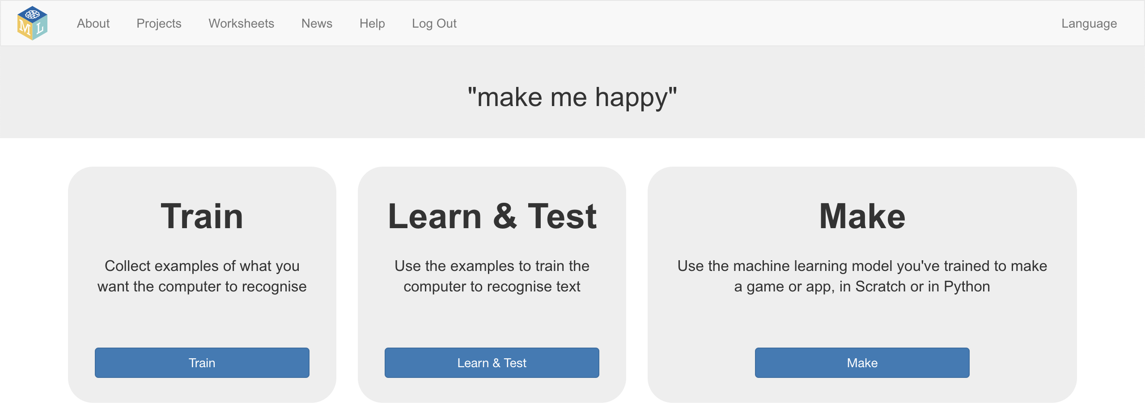
10. Click on **“+ Add new label**” and call it “kind things”.   
    Do that again, and create a second bucket called “mean things”.  
    
11. Click the “**Add example**” button in the “kind things” bucket, and type in the nicest, kindest compliment that you can think of.  
    
12. Click on the “**Add example**” button in the “mean things” bucket, and type in the meanest, cruellest message that you can think of.
13. Repeat steps 11 & 12 until you’ve got at least **six** examples of each.  
    
14. Click on the **“< Back to project**” link.   
    Then click on the “**Learn & Test**” button.
15. Click on the “**Train new machine learning model**” button.   
    *As long as you’ve collected enough examples, the computer should start to learn how to recognise messages from the examples you’ve given to it.  
    *
16. Wait for the training to complete. This might take a few minutes.
17. Once the training has completed, a Test box will be displayed.   
    Try testing your machine learning model to see what the computer has learned.   
    Type something kind, and press enter. It should be recognised as kind.  
    Type something mean, and press enter. It should be recognised as mean.  
     *Test it with examples that you haven’t shown the computer before.   
    If you’re not happy with how the computer recognises the messages, go back and add some more examples.*



1. Click the “**< Back to project**” link
2. Next, we’ll use Python. Click “**Make**”  
   
3. Click on the “**Python”** button
4. Click on the “**Copy code to run on your computer**”  
   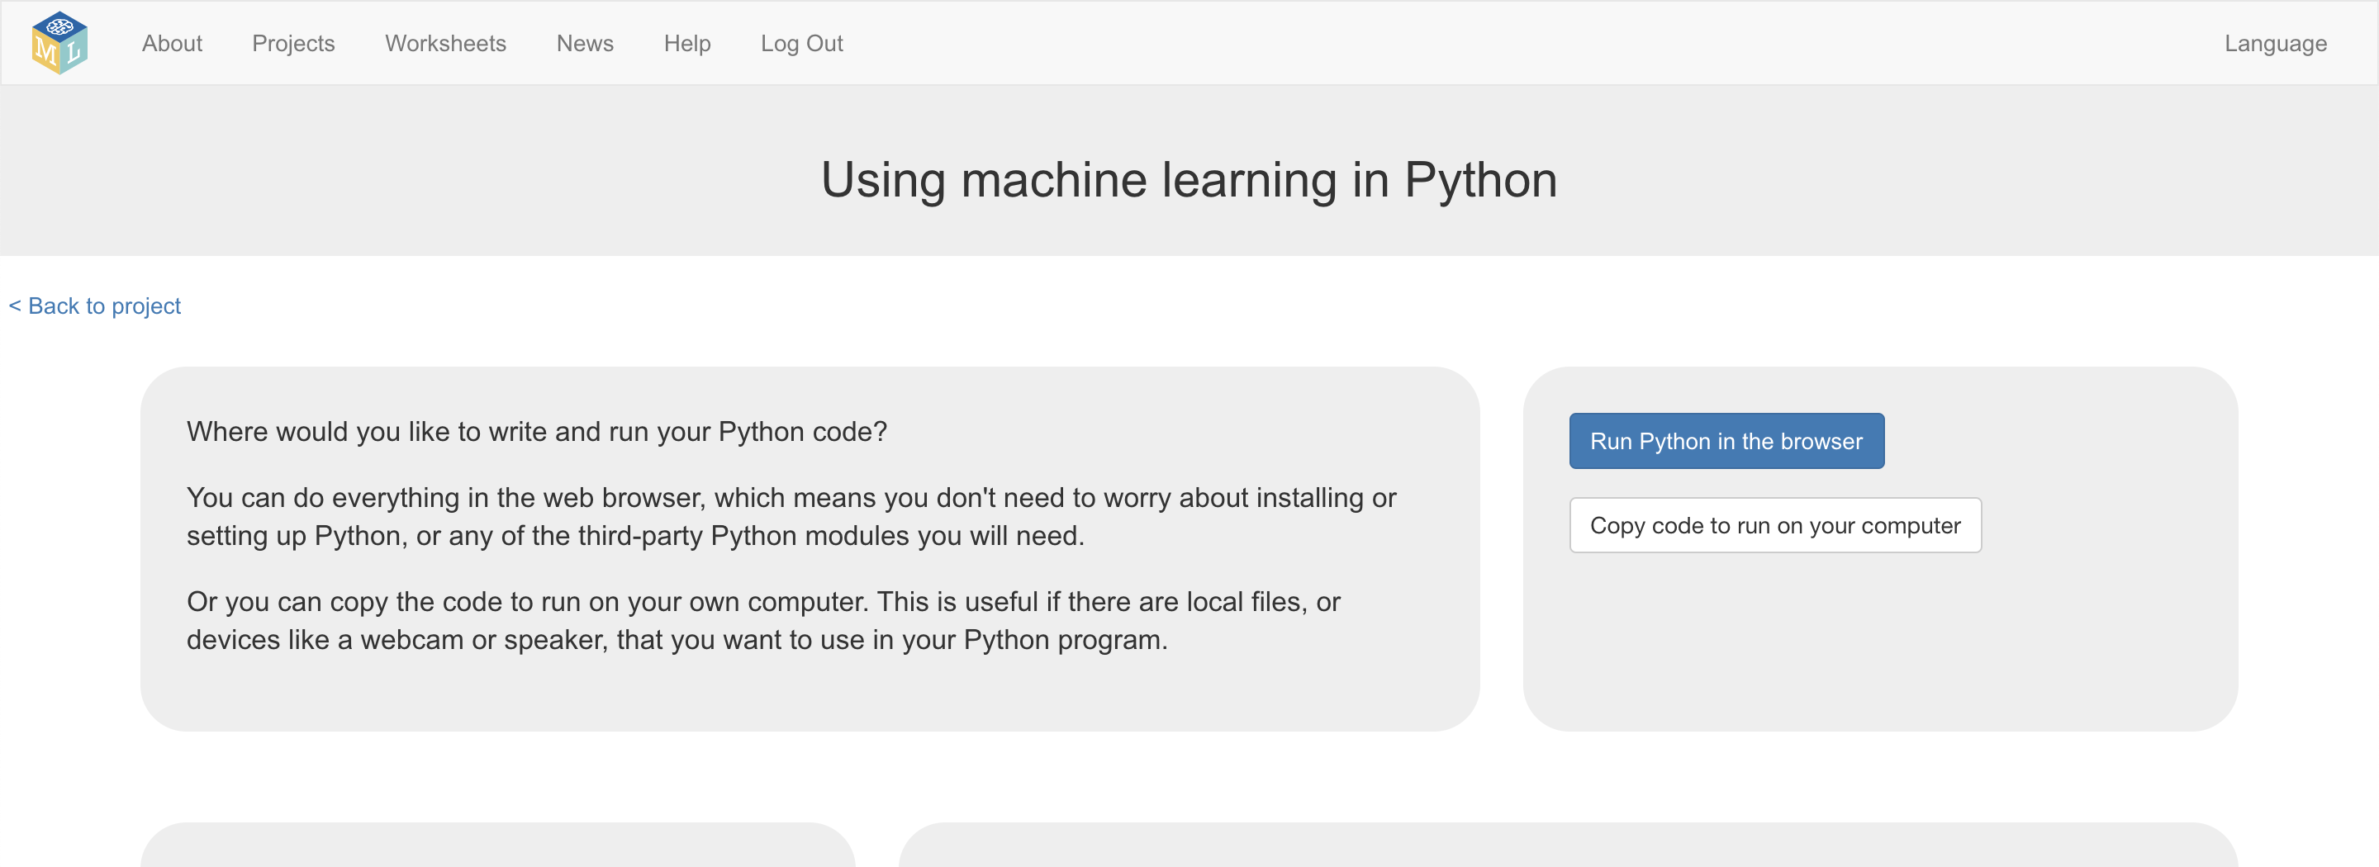
5. Copy the skeleton code displayed into a text editor.   
   Save it as a file called **makemehappy.py**  
   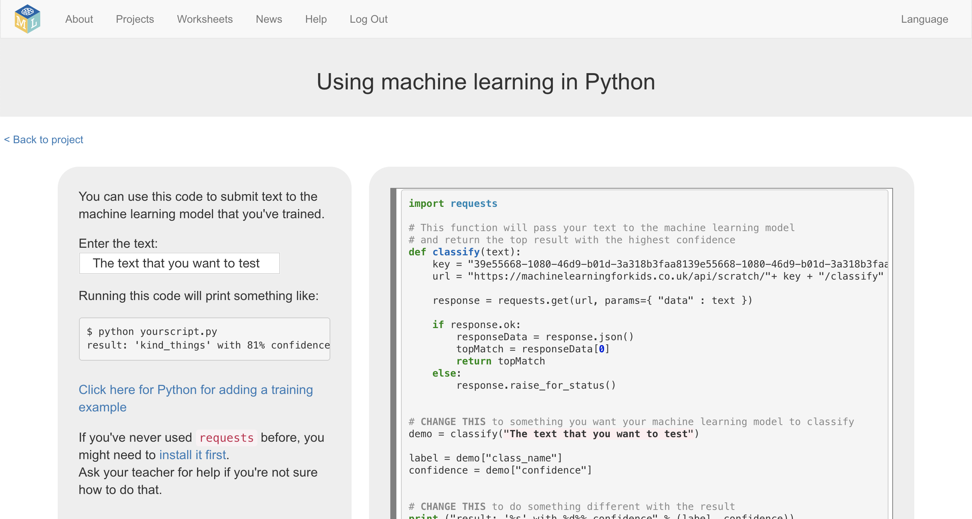
6. Delete the bottom half of the code   
   *Everything from* **# CHANGE THIS** *to the end of the file, highlighted below. Delete it, as you won’t need it.*
7. You will be using a Python library called **Pillow** to display your pictures. If you don’t already have it installed, you need to do this now.   
   *Ask your teacher or group leader to help. Instructions can be found at* [*https://pillow.readthedocs.io/en/stable/installation.html*](https://pillow.readthedocs.io/en/stable/installation.html#basic-installation)
8. Add “**from PIL import Image**” to the top of your code  
   
9. Add this to the end of your code.  
   *It will ask you to type in a message.   
   The message you type in will be stored in a variable called “input”.   
   That variable will be given to the machine learning model that you have trained so it can try to recognize it.   
   If the machine learning model recognizes it as a compliment, your program will display a “You’re so nice” message and show your picture of a happy face.*  
     
   You need to update **happy.png** and **sad.png** to **match the names of your pictures** of faces.  
     
    **input = raw_input("What do you want to tell me? > ")  
     
    recognized = classify(input)  
     
    label = recognized["class_name"]  
     
    if label == "kind_things":  
    print ("You're so nice!")**

**img = Image.open("happy.png")**

**img.show()**

**else:**

**print ("You're so mean!")**

**img = Image.open("sad.png")**

**img.show()**

1. Run your program with the command: **python makemehappy.py**   
     
   

**What have you done?**

You’ve made a Python program that asks for the users input. It will then use the machine learning model that you trained to recognize whether what the user inputted was a compliment or an insult. This is often described as “sentiment analysis”.

The more examples you give it, the better it should get at recognising messages correctly.

**Ideas and Extensions**

Now that you’ve finished, why not give one of these ideas a try?

Or come up with one of your own?

**Write a reply**

Instead of just changing the way they look, make your character reply, based on what it recognises in the message!

**Try a different character**

Instead of a person’s face, why not try something different, like an animal?

It could react in different ways, instead of smiling.

For example, you could make a dog that wags their tail if you say something kind to it!

**Different emotions**

Instead of kind and mean, could you train the character to recognise other types of message?

**Real world sentiment analysis**

Can you think of examples where it’s useful to be able to train a computer to recognise the emotion in writing?